

**Design and Testing Document**

Topic: Fitness - Gym and Nutrition

Website: <http://gymandnutrition.com>

CA 3: Usability Design Project Deliverable 2

***Team Project****:*

Navjot Singh (x13112406)

Soffyan Ali (x13114503)

***Submitted to:***

Leone Deasy

Table of Contents

1 Executive Summary 2

2 Prototyping 2

Low-fidelity Prototype 2

Wireframe 1 2

Wireframe 2 2

Wireframe 3 2

High-Fidelity Prototype 2

Prototype 2

3 Testing 2

Techniques 2

Five Second Test 3

Here 3

Trunk Test 3

Think Aloud 3

Video/Screening recording 3

Heuristic Evaluation 3

4 Conclusion 3

5 Appendix A 3

Consent Form 3

Consent Form 3

# Executive Summary

Staying well and fit is every human being’s dream, looking good in every outfit and be able to present just the way we imagine ourselves in our thoughts in mind but daily work and stress sometimes keeps us away from fulfilling all those dreams and we wish “if there was a tool that could guide me and save time searching around on Google and provide me all fitness, nutrition and gym related information and news on one place would be great”.

So, backing this idea, we have decided to develop a website platform that would provide fitness, gym and nutrition information all on one site and on top of it the users will also have the option to clear their confusions and ask answers to their questions from experts and other users on the website. Our goal is to keep the website as simple and usable as possible in order to serve users with different levels of technical skills or minimal technical skills as we would also be aiming to help our elderly to be able to navigate the site easily and benefit from the site (example: font resizer function).

***The aim of this report is to discuss design principles and patterns implemented and provide design prototypes and conduct usability testing on the system.***

Let’s, start with prototyping and alongside we will provide details and discuss design principles & patterns used in prototyping of the system-

# Prototyping

## Low-fidelity Prototype

The low-fidelity prototype section contains 3 wireframes of the system been designed and tested in this report.

### Wireframe 1

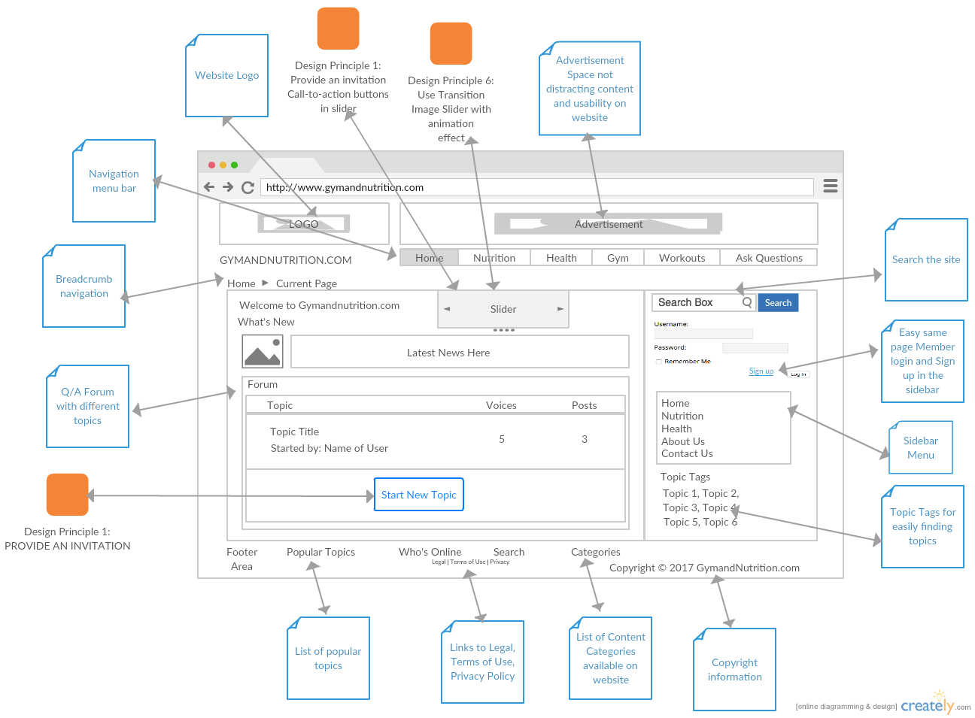

### Wireframe 2

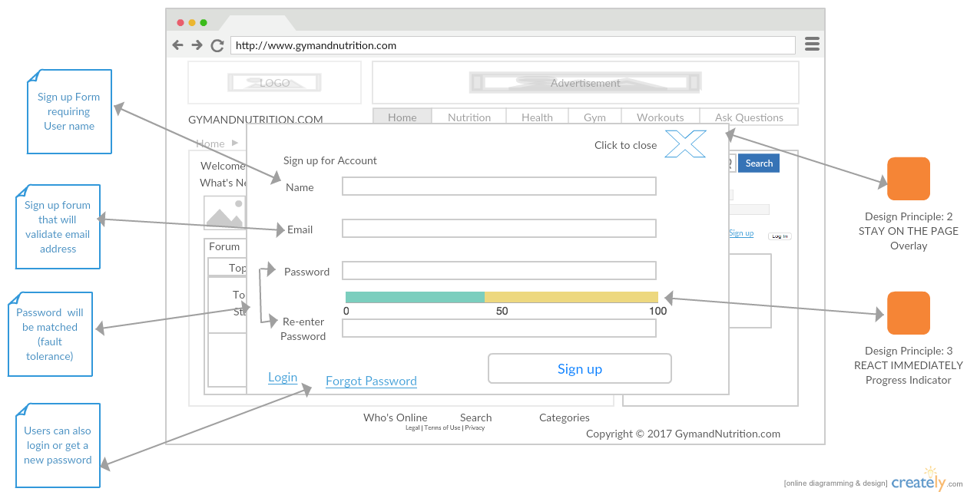

### Wireframe 3

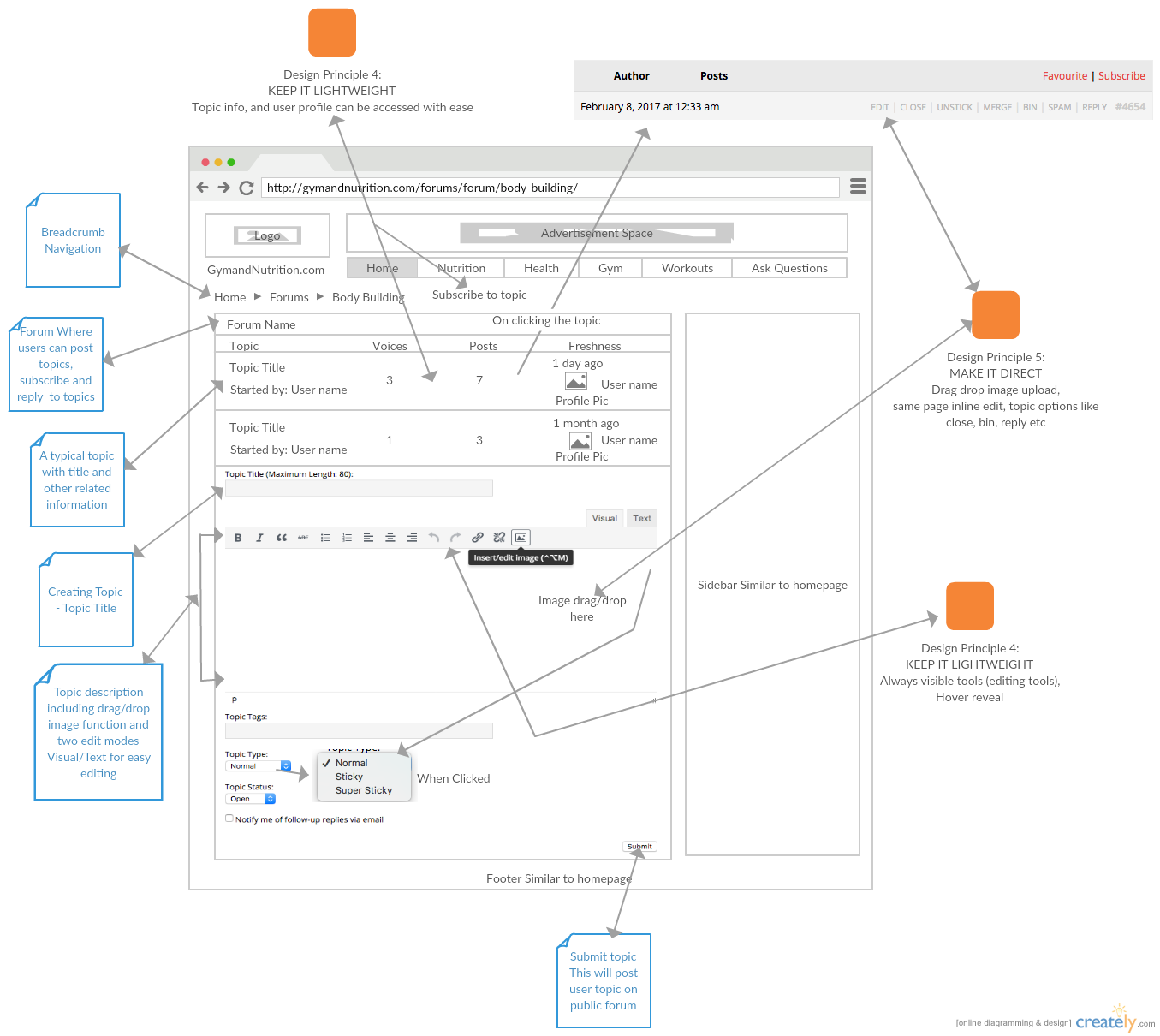

## High-Fidelity Prototype

### Prototype

# Testing

## Techniques

As part of the report, we have decided to acknowledge two methods that comply in Data gathering techniques which are based on an interview and a survey. The interview will be on five participants questioning on them of how they find the importance of nutrition in their life. And how often they would exercise to live a healthy balanced life.

We have designed a survey form for the improvements and knowing what people’s thoughts are towards their nutrition diet and exercise. This will benefit our website to know the customer demanding needs which will bring improvements.

**The Consent form filled by every subject that participated in this study is available in the Appendix A of this document.**

## Five Second Test

## Here

## Trunk Test

Here

## Think Aloud

Here

### Video/Screening recording

Link/File name

## Heuristic Evaluation

Here

# Conclusion

# Appendix A

## Consent Form

Form filled and submitted by every subject that participated in this study, voluntary interviews and usability testing.

|  |  |
| --- | --- |
| Consent Form | |
| (Usability Design Prototype Design and Testing)  Consent Form  I ………………. agree to participate in the prototype and testing research study carried by Navjot Singh and Soffyan Ali for their Usability design project. The purpose and nature of the study has been explained to me. And I understand and agree that my participation is voluntary and I am completely free to refuse or opt out of the study anytime.  I give permission for my interview to the research team.  I understand that the data collected from my participation may be used for purposes like thesis, journal publication etc.), and I consent it to be used in that manner. | |
| Signed  ……………… | **Date**  **.…/…../20….** |
| Name (please print your Full name in CAPITAL LETTERS)  ……….. | |